
http://dx.doi.org/10.35596/1729-7648-XXXX-XX-X-XX-XX
UDC (the authors indicate)

TITLE OF THE ARTICLE (in English)

NAME, SURNAME (of all authors)
Full name of the institution (City, Country)

Abstract. Abstract text in English.
Keywords: list of keywords in English (up to 15 words).
Conflict of interests. The authors declare no conflict of interests.
For citation. Ivanov I. I., Petrov P. P., Sidorov S. S. (2025) Article title. Digital Transformation. 31 (1), 10–15. http://dx.doi.org/10.35596/1729-7648-2025-31-1-10-15.

Introduction
Text of the article.

Methods of conducting experiment
An example of drawing pattern is shown in Fig. 1.

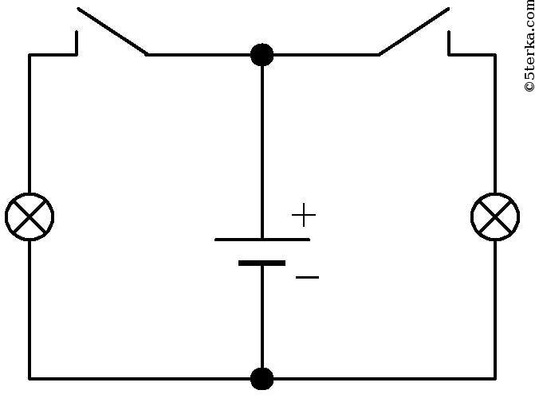
Fig. 1. An example of figure design

An example of registration of the formula (formulas are recruited in the MathType editor):
(1)
An example of a table is presented in table. 1.

Table 1. Example of table design
Column 1 name | Column 2 name | Column 3 name
Column content 1 | Column content 2 | Column content 3

Experimental results
Text…

Conclusion
Text…
Gratitude. Text of gratitude in English (if necessary).

References

(Up to 15 sources (only monographs and articles from peer-reviewed publications)

Example of design
1. Mironova A. L., Gavrilyuk E. Yu., Guslyakova A. V., Svalova A. S., Gonchar V. N. (2020) Application of Simulation Modeling Tools in Optimizing Business Processes. Economics and Management of the Natio-nal Economy. (11), 49–53 (in Russian).
2. Listopad N. I., Bushchyk E. A. (2023) Model of Educational Process Management in Institutions of Secondary Special Education. Digital Transformation. 29 (2), 52–59. http://dx.doi.org/10.35596/1729-7648- 2023-29-2-52-59 (in Russian).
3. Pereverzev P. P. (2015) The Use of the Matrix Approach for Modeling and Analysis of the Relationships Between Structures of Enterprise. International Research Journal. 41 (10-1), 63–67 (in Russian).
4. Ivanov P. V., Dashkova I. A., Tkachenko I. V., Kostylev V. I. (2022) Methods of Making Management Decisions. Moscow, Yurait Publishing House (in Russian).
5. Anand S., Burke E., Chen T., Clark J., Cohen M., Grieskamp W., et al. (2014) An Orchestrated Survey on Automated Software Test Case Generation. Journal of Systems and Software. Elsevier. C-39 (4), 582–586.

Authors’ contribution

Create information about the contribution of each author to work.

For example: Surname N. performed the task for the study, prepared the manuscript of the article.
Information about the authors

The author's surname and initials in English, academic degree, academic title, position indicating the name of the institution in English.
Address for correspondence
Index, country name in English,
city name in English, street name in English, house number,
full name of the institution in English
telephone number indicating country and city codes (mobile operator);
e-mail:
SURNAME, NAME, patronymic of the contact author in English

